IE 441

PLANNING FOR ENGINEERS

INSTRUCTOR:TANER BİLGİÇ

Homework 2

SİNAN DEMİRHAN

2016402330

**1-)**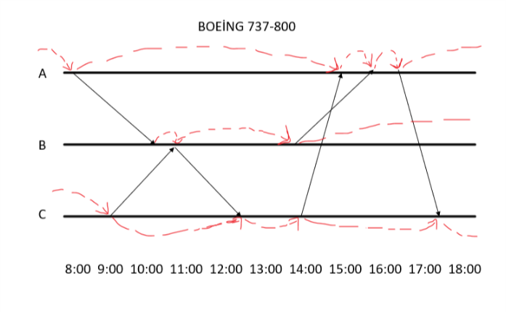

There are 6 flight assignment and 13 ground variables in Boeing 737-800 type airplane

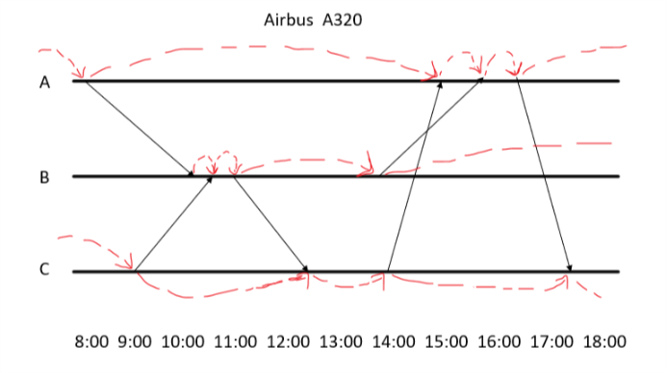

There are 6 flight assignment and 14 ground variables in Airbus A320 type airplane

**2-)**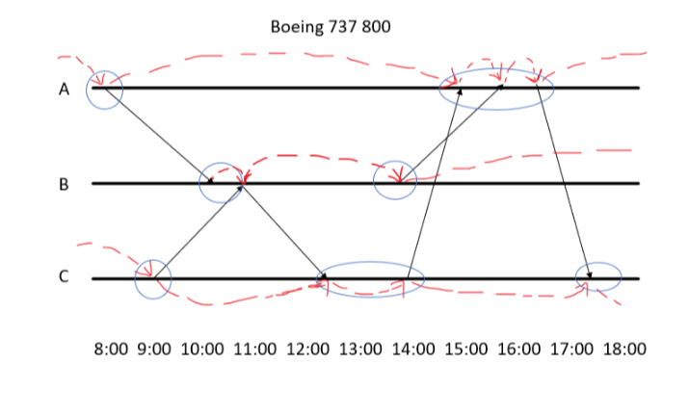

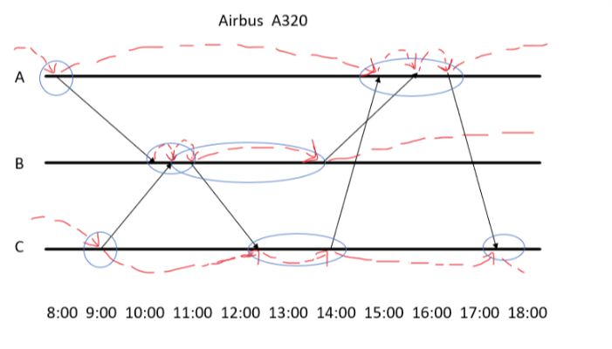

The nodes and their regarding timelines are circled. The number of ground variables decreases to 7 for Boeing and Airbus and the fleet assignment stays the same for both of them.

**3-)**

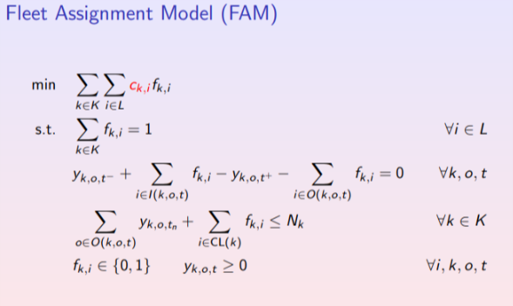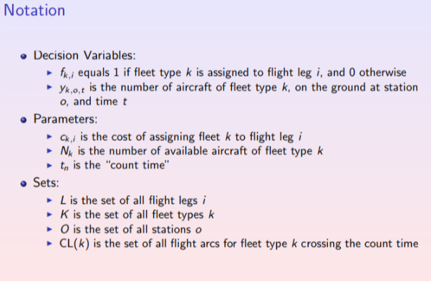

**4-)**

CODE

parameters:

plane := 1(1)2;

leg := 1(1)6;

ABC := 1(1)3;

time := 1(1)10;

a[plane, leg] := ((59850, 57840, 65520, 59136, 43840, 31500),

(54000, 56200, 64300, 54000, 36000, 36000));

TF[plane] := (2, 2);

variables:

x[plane, ABC, time] : integer[0..];

y[plane, leg] : binary;

objectives:

sum{i in leg, g in plane : y[g, i] * a[g, i]} -> min;

constraints:

{i in leg : sum{g in plane : y[g, i]} = 1;}

{g in plane : x[g, 1, 1]- x[g, 1, 2] - y[g, 1]=0 ;}

{g in plane : x[g, 3, 9] + y[g, 6]- x[g, 3, 10] = 0;}

{g in plane : x[g, 1, 2] + y[g, 4] + y[g, 5]-x[g, 1, 3] - y[g, 6] = 0;}

{g in plane : x[g, 2, 4] + y[g, 1] + y[g, 2]- x[g, 2, 5] - y[g, 3] =0;}

{g in plane : x[g, 2, 5]- x[g, 2, 6] - y[g, 4] =0;}

{g in plane : x[g, 3, 7]- x[g, 3, 8] - y[g, 2]= 0;}

{g in plane : x[g, 3, 8] + y[g, 3] -x[g, 3, 9] - y[g, 5]= 0;}

///////////////////////////////////////////////////////////

{g in plane : x[g, 1, 1] -x[g, 1, 3]= 0;}

{g in plane : x[g, 2, 4] - x[g, 2, 6]=0;}

{g in plane : x[g, 3, 7] -x[g, 3, 10]= 0;}

////////////////////////////////////////////////////////////

{g in plane : x[g, 1, 1] + x[g, 2, 4] + x[g, 3, 7] <= TF[plane];}

SOLUTİON

Problem FAM.cmpl

**Nr. of variables 32**

**Nr. of constraints 30**

Objective name line[1]

Solver name CBC

Display variables (all)

Display constraints (all)

---------------------------------------------------------------------------------------------------------

Objective status optimal

**Objective value 300500 (min!)**

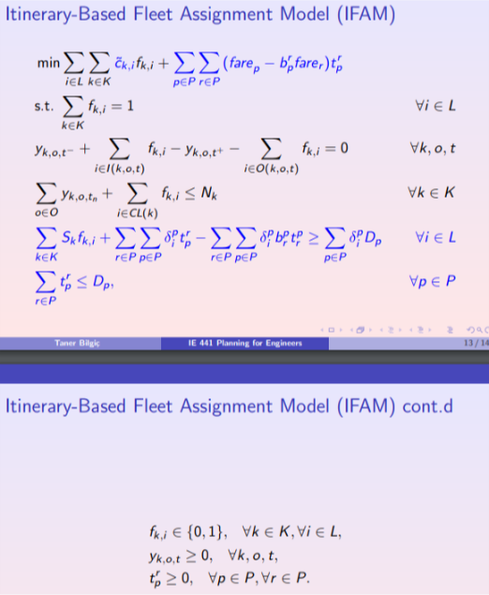**5-)**

CODE

parameters:

plane := 1(1)2;

leg := 1(1)6;

ABC := 1(1)3;

time := 1(1)10;

TF[plane] := (2, 2);

a[plane, leg] := ((42000, 36000, 36000, 42000, 24000, 24000),

(54000, 52000, 52000, 54000, 36000, 36000));

seat[plane] := (108, 150);

IT := 1(1)8;

NP[IT] := (90, 60, 90, 70, 120, 80, 140, 120);

fare[IT] := (450, 800, 450, 800, 450, 450, 700, 700);

IT := 1(1)8;

B[IT, leg] := ((1, 0, 0, 0, 0, 0),

(1, 0, 1, 0, 0, 0),

(0, 1, 0, 0, 0, 0),

(0, 1, 0, 1, 0, 0),

(0, 0, 1, 0, 0, 0),

(0, 0, 0, 1, 0, 0),

(0, 0, 0, 0, 1, 0),

(0, 0, 0, 0, 0, 1));

variables:

x[plane, ABC, time]: integer[0..];

y[plane, leg]: binary;

z[IT]: integer[0..];

objectives:

sum{i in leg, g in plane : y[g, i] * a[g, i]} + sum{j in IT: fare[j] * z[j]} -> min;

constraints:

{i in leg : sum{g in plane : y[g, i]} = 1;}

{g in plane : x[g, 1, 1]- x[g, 1, 2] - y[g, 1]=0 ;}

{g in plane : x[g, 3, 9] + y[g, 6]- x[g, 3, 10] = 0;}

{g in plane : x[g, 1, 2] + y[g, 4] + y[g, 5]-x[g, 1, 3] - y[g, 6] = 0;}

{g in plane : x[g, 2, 4] + y[g, 1] + y[g, 2]- x[g, 2, 5] - y[g, 3] =0;}

{g in plane : x[g, 2, 5]- x[g, 2, 6] - y[g, 4] =0;}

{g in plane : x[g, 3, 7]- x[g, 3, 8] - y[g, 2]= 0;}

{g in plane : x[g, 3, 8] + y[g, 3] -x[g, 3, 9] - y[g, 5]= 0;}

///////////////////////////////////////////////////////////

{g in plane : x[g, 1, 1] -x[g, 1, 3]= 0;}

{g in plane : x[g, 2, 4] - x[g, 2, 6]=0;}

{g in plane : x[g, 3, 7] -x[g, 3, 10]= 0;}

////////////////////////////////////////////////////////////

{g in plane : x[g, 1, 1] + x[g, 2, 4] + x[g, 3, 7] <= TF[plane];}

////////////////////////////////////////////////////////

{g in plane: x[g,1,1] + x[g,2,4] + x[g,3,7] <= TF[plane];}

{i in leg: sum {g in plane : y[g, i] * seat[g]} + sum{j in IT : B[j, i] * z[j]} >= sum{j in IT : B[j, i] * NP[j]};}

{j in IT : z[j] <= NP[j];}

SOLUTİON

Problem IFAM.cmpl

**Nr. of variables 40**

**Nr. of constraints 48**

Objective name line[1]

Solver name CBC

Display variables (all)

Display constraints (all)

---------------------------------------------------------------------------------------------------------

Objective status optimal

**Objective value 302000 (min!)**

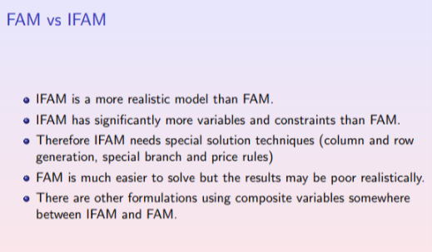**We can easily see that ın FAM there are 32 variable and 30 consraints.In IFAM there are 40 variable and 48 constraints**

**6-)**

We saw these results from our example.We solved our problem by using FAM and IFAM and saw the results for both of them.Because we added spill costs, our variables and constraints increased and this situation made our solution more complex but more realistic.

Since the difference between the solutions is less ,using FAM for these type of problems(problems with less variable,less flight or less constraint)can be more logical.

We can see realiability and solvability relationship between FAM and IFAM from the TABLE A.

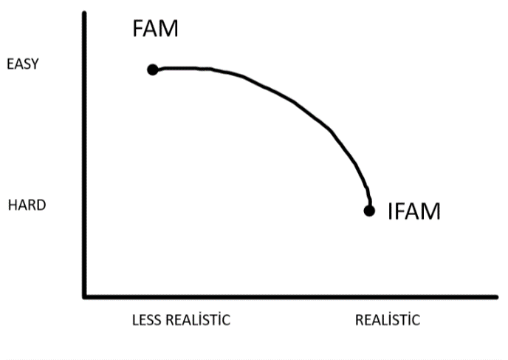

TABLE A

**7-)**

Of course this situation will decrease the overall cost thanks to the decrease in the spill cost and can be seen as an improvement in comparison to the solution in question 5.